Behaviour 1 Tutorial

This tutorial will teach you step by step on how to make a behaviour where a chaser will chase a player.

Step 1: Create a floor, a cube (chaser), a capsule (player) with 3D objects. And re-name them as such.

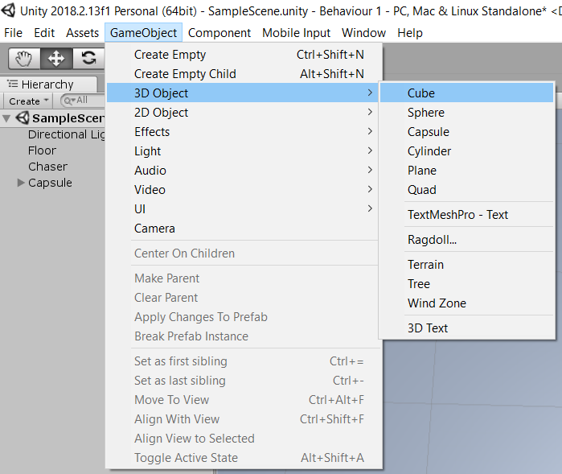

Optional: I recommend switching to top down view, it will make it easier to see the two objects. Simply click on the Y axis circled.

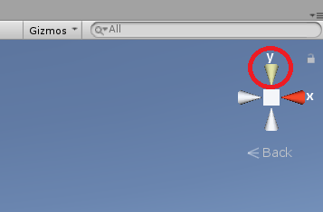

Step 2: On the chaser, add in a new component called Rigidbody.

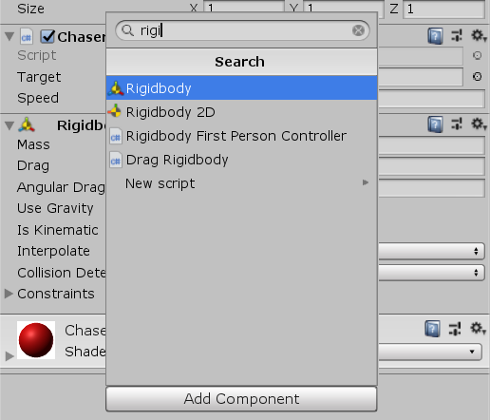

Step 3: Create a new C# script for the chaser and name is chaser.

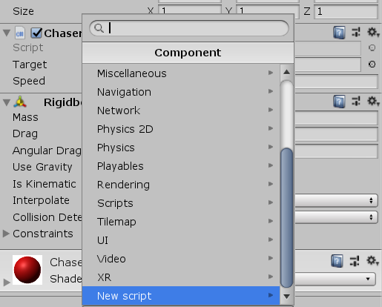

Step 4: Open the chaser script in either MonoDevelop or Visual Studio.

We don’t need the start function, so you can delete them.

We will only need to declare 2 variables which we will use to store data.

*public float speed \**we will use this to set the speed to chaser will move towards the player

*public targetTransform \**We will use this to store the location of our player

*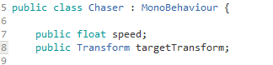*

Next, we will make a void and we’ll call it follow. Under the void follow, we will have the chaser constantly moving forward but also making the play always face the player. This way, the chaser will always move towards the direction of the player.

*void follow(){*

*transform.Translate (Vector3.forward \* Time.DeltaTime \* speed); \**This will make the chaser move forward at the speed we set.

*Transform.LookAt (targetTransform); \**This will make the chaser always face the player

*}*

*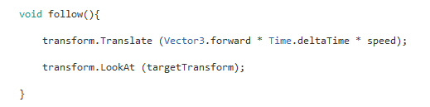*

Lastly, we will run the follow code every frame. Under void Update, we will put in the follow function.

void Update(){

follow();

}

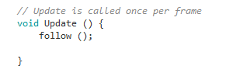

Step 5: Type in the speed you want the chaser to move in. click and drag the player from the hierarchy into the transform variable in chaser under the inspector.

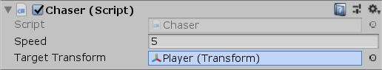

Step 6: Select the player under the hierarchy.

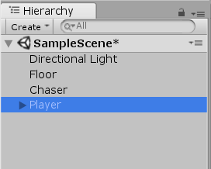

Click play.



The chaser will now chase the player. Click and drag the centre of the player to move the player around.

